St Andrews Marlesford Churchyard Count on Nature

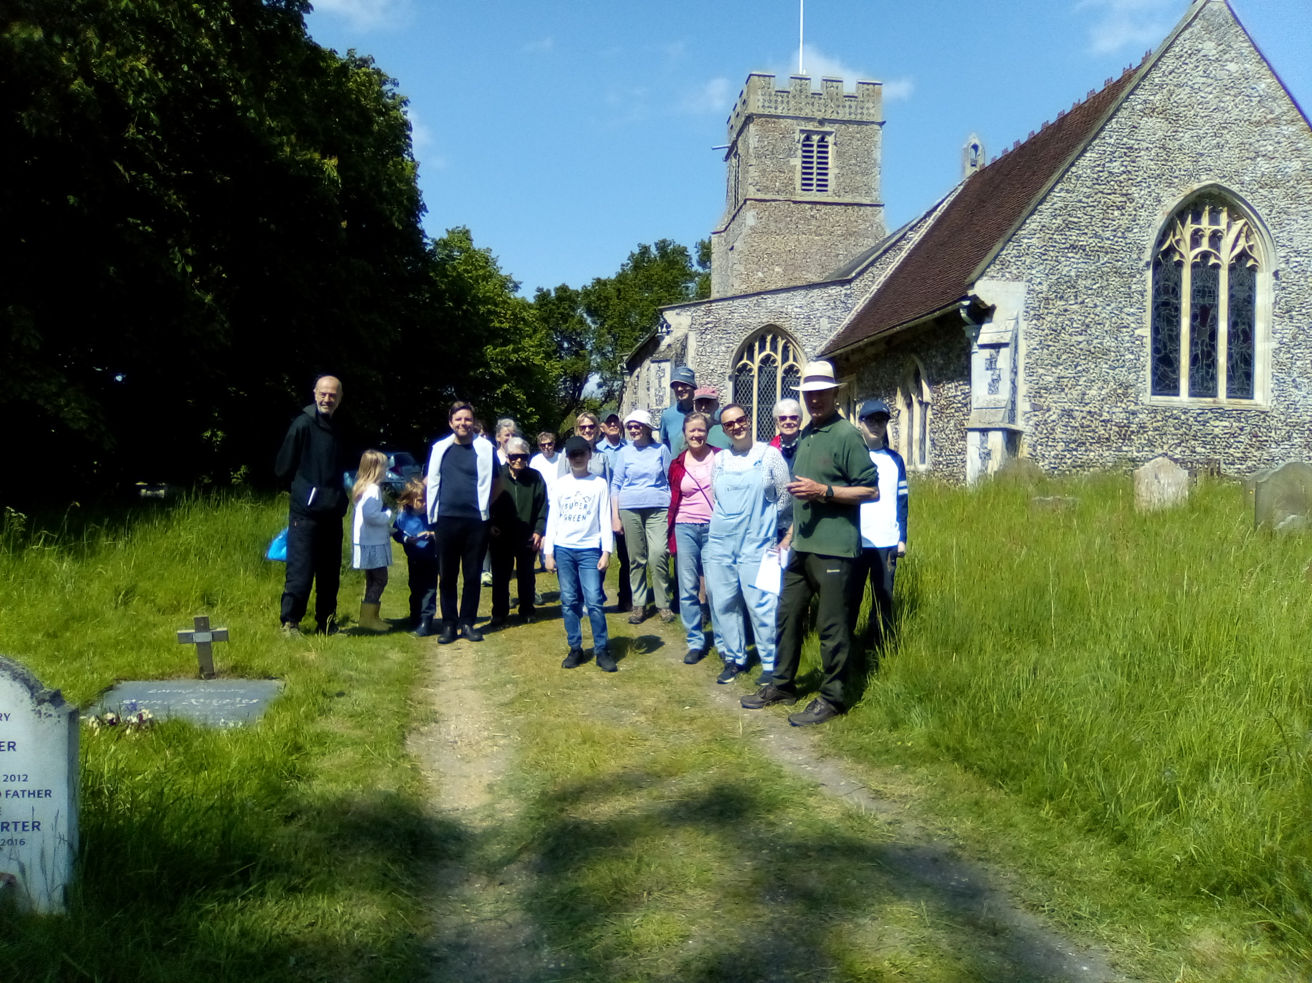
On a glorious Saturday morning at the beginning of June, St Andrews churchyard couldn’t have looked more peaceful or more beautiful. Eighteen of us turned out to celebrate the special flora of the churchyard by carrying out a Nature Count. The idea came from Caring for God’s Acre, a national charity dedicated to looking after churchyards and other burial grounds, the aim being to record as much as possible about the flowers and wildlife in our sacred spaces around the Country.
Introducing the count, Richard Cooper explained that churchyards have been allowed to develop distinct floras as they are largely undisturbed apart from burials (in the case of Marlesford, the history probably goes back more than 1,000 years) and are generally left unfertilised – an important factor in encouraging a diverse range of wildflowers.
We were extremely lucky to be guided on our count by Susan Stone from Suffolk Wildlife Trust – without her, we would have struggled to identify some of the plants we found! Commenting on the special nature of Marlesford’s churchyard, Susan said that “Marlesford churchyard is a good example of a wildflower-rich grassland and the number of species found is testament to the careful conservation management that the parish undertakes.”
Overall we counted 56 species of wildflowers, 13 species of grasses, 13 different types of trees and 19 birds recorded in a 15 minute spell.
The reward was a fantastic ploughman’s lunch produced by Carol Cooke and enjoyed with a glass of beer in the sunshine.
The churchyard has a truly diverse fauna and flora, but you don’t have to be an expert to enjoy it – when you next have time, do take a stroll over the cut paths to the north of the church and see what you can find. You will probably surprise yourself when you see how much life there is in a small patch of ground.
Richard Cooper
richardccooper@hotmail.co.uk

